**Assessment 1: Research Project Proposal**

Automating Physiological Data Collection from Human Reactions to Environmental Stimuli

|  |  |
| --- | --- |
| Name: | Supervisor: |
| ID: |  |
| Word Count: 2936 (Without References) |  |
| Date: |  |

Table of Contents

Table of Figures 2

Abstract 3

Introduction 3

Background 4

Aims and Objectives 4

Research Questions 4

Ethical Considerations 5

Literature Review 5

LR-01 Machine learning approaches to understand the influence of urban environments on human’s physiological response. 5

LR-02 Psychological and physiological human responses to simulated and real environments: A comparison between Photographs, 360 Panoramas, and Virtual Reality. 10

Project Timeline 12

Methodology 12

Dataset 12

Machine Learning 12

GUI 13

Project Evaluation 13

Conclusion 13

References 13

# Table of Figures

Figure 1 - Research Framework 6

Figure 2 - Performance Metrics for REP-Trees 8

Figure 3 - Results obtained from visualizing fuzzy rules 9

Figure 4 - Trained SOM Results 9

Figure 5 - Summary of the Experiment in this research 10

Figure 6 - Results as psychological responses. 10

Figure 7 - Project Timeline 11

Figure 8 - Convolutional Neural Network Workflow 12

# Abstract

A lot of human conduct is guided by nonconscious cycles. Social exploration can subsequently be intricate. Utilizing programming to improve on the mind-boggling human conduct can give scientists admittance to passionate, psychological and social information in a combined method to take advantage of constant human encounters.

Micro-expressions are the key to understanding best how humans involuntarily react to stimuli from the environment. This study can boost behavioural mechanics studies to great heights. Micro-expressions are small, involuntary facial expressions that humans make while reacting to a feeling induced through an environmental stimulus. Since these reactions are involuntary, therefore humans have no control over them and thus they cannot be faked.

This research proposal combines Machine Learning and Software Design to create an app that can automate the process of simplifying complex human behaviour by designing an application similar to iMotions using Python and Machine Learning libraries like tensor-flow, Keras and scikit-learn. It applies these automation techniques to real-time images of involuntary human reactions to various stimuli to record and create a dataset from micro-expressions that will be captured by the camera in the application. These micro-expressions will be categorized based on the OASIS dataset.

The output of this research will be a full-fledged software that can record real-time human micro-expressions using Facial recognition through a camera, tag the image with the expression using its training from the OASIS dataset and create a dataset that can be used for further behavioural research and study.

**Keywords:** Facial Recognition, Behavioral Research, Behavioral Mechanics, Stimuli

# Introduction

Understanding the impact of the ecological conditions on human insight is unpredictable. Different natural highlights, e.g., sound level, temperature, and illuminance influence our faculties. Consequently, researchers embraced improved estimation and examination procedures to characterize and gauge what impacts residents in powerful metropolitan conditions. The natural highlights estimated in this examination incorporate sound level, dust, temperature, stickiness, illuminance and the field-of-see since they impact an individual's feeling that, in this exploration, was addressed by the physiological condition of an individual, which was estimated through electro-dermal movement (EDA) (Ojha et al., 2019).

The mental examination into human factors now and again utilizes reenactments to consider the connection between human conduct and the climate. Their legitimacy relies upon their comparability with the physical conditions. Natural reenactments obtain an applicable job in ecological brain research as they permit us to reproduce and concentrate in disengagement and in a controlled manner the impacts of room on human experience (Higuera-Trujillo, López-Tarruella Maldonado and Llinares Millán, 2017). The legitimacy of these recreations is identified with its ability to summon a member's reaction like the one that the space it is reproducing would (Higuera-Trujillo, López-Tarruella Maldonado and Llinares Millán, 2017).

This rationale depends on 'conduct authenticity': the setting in which an ecological recreation is better the more comparative the client will react to it contrasted with the addressed climate (Higuera-Trujillo, López-Tarruella Maldonado and Llinares Millán, 2017). In this sense, new natural portrayal advancements address this issue through the improvement of the feeling of the essence, the visual experience (Higuera-Trujillo, López-Tarruella Maldonado and Llinares Millán, 2017), and the communication with the addressed spaces, permitting clients to unreservedly act inside them (Higuera-Trujillo, López-Tarruella Maldonado and Llinares Millán, 2017).

These issues highlighted in previous researches cannot be observed or recorded using normal methods since people have different reactions to them. Recording micro-expressions of people facing these issues and categorizing the micro-expressions can provide us with a deep insight into what the people are thinking and what problems are the people facing. There are many more applications for behavioural research regarding micro-expressions. This research project aims at assisting the behavioural research domain by automating the process of micro-expression data collection and classification.

## Background

Micro-expressions, the short-lived and compulsory outward appearance, regularly happening in high-stake circumstances when individuals attempt to cover or veil their actual emotions, turned out to be notable since the 1960s. Micro-expressions are excessively short (1/25 to 1/2 s) and unpretentious for natural eyes to see. Study shows that for miniature articulation acknowledgement undertakings, normal individuals without preparing just perform somewhat better compared to risk overall. So PC vision and AI techniques for programmed miniature articulation examination become engaging (Zhao and Li, 2019).

Micro-expression study in the computer-vision field has been drawing in considerations from an ever-increasing number of scientists. Various works have been adding to the programmed micro-expressions investigation from the parts of new datasets assortment, miniature articulation and micro-expression location. Be that as it may, there are as yet many open difficulties that should be considered later on for research (Zhao and Li, 2019).

## Aims and Objectives

This research project aims to create a web-based application that combines a Machine Learning (ML) algorithm/ensemble trained on the OASIS dataset to categorize micro-expressions and a camera that can provide real-time micro-expressions as input for the ML. This web-based app will record real-time micro-expressions and classify them based on training from the OASIS dataset and create a dataset that can be used for behavioural mechanics study. To achieve this, the following steps are traced:

* Literature Review is done to understand the previous approaches to this problem and to understand in-depth micro-expressions.
* Designing the Front-end of the project. This involves designing mockups that will make up the GUI of the final app.
* Designing the Machine Learning Algorithm/Ensemble and training it on the OASIS dataset. The machine-learning algorithm has to be very efficient in training since there isn’t much data to train on.
* Testing the algorithm performance using Performance metrics like confusion matrices. The evaluation of the dataset created will also be an evaluation point for this project.

## Research Questions

The following research questions will guide the direction this project will take:

1. Can machine learning effectively automate the process of collecting physiological data?
2. Will the dataset created by machine learning be good enough to provide good insights for behavioural sciences?

## Ethical Considerations

The data in this project is being collected through a study called the OASIS study. This study records the micro-expressions of the people in response to various environmental stimuli the people aren’t aware of. This data collected is then used in this project to develop software that can collect micro-expressions data from people. The General Data Protection Regulation (GDPR) has ethical policies for this in Chapter 3: Rights of the data subject. This chapter is summarized below:

* Area 1: Transparency and modalities
  + Article 12 — Transparent data, correspondence and modalities for the activity of the privileges of the information subject
* Area 2: Information and admittance to individual data
  + Article 13 — Information to be given where individual information is gathered from the information subject
  + Article 14 — Information to be given where individual information has not been acquired from the information subject
  + Article 15 — Right of access by the information subject
* Segment 3: Rectification and eradication
  + Article 16 — Right to correction
  + Article 17 — Right to eradication ('option to be neglected')
  + Article 18 — Right to limitation of preparing
  + Article 19 — Notification commitment in regards to correction or deletion of individual information or limitation of preparing
  + Article 20 — Right to information convenience
* Segment 4: Right to protest and computerized singular dynamic
  + Article 21 — Right to protest
  + Article 22 — Automated individual dynamic, including profiling
* Segment 5: Restrictions
  + Article 23 — Restrictions

The software must adhere to these principles from the GDPR, ask for permission and consent before data collection from the user.

## Literature Review

The significance of the Literature review comes from the fact that a good LR can provide validity for the integrity of the research. It can provide contingency plans for errors that might occur during research before they even occur. Learning from the experience of other researchers through their papers is what LR is.

### LR-01 Machine learning approaches to understand the influence of urban environments on human’s physiological response.

This examination proposes a structure for signal preparing and data combination of spatial, temporal multi-sensor information relating to understanding examples of people physiological changes in a metropolitan climate. The system incorporates signal recurrence unification, signal matching, signal sifting, signal evaluation, and information marking. In rundown, coming up next are three fundamental commitments of this examination:

* a field study plan for understanding human view of the metropolitan climate;
* a system configuration involving signal handling, signal evaluation, and information combination strategies that summons a novel approach in physiological information measurement;
* A far-reaching investigation utilizing four AI strategies to find the examples which are critical to our comprehension of human insight in metropolitan settings.

#### Methodology

A thorough sign handling and information preprocessing structure were proposed to apply select machine learning strategies. Figure 1 represents the structure and portrays how it was utilized for data combination and information mining draws near.

1. Each members' occasion-based information (e) is gathered from five sensors, which were re-inspected to a one-of-a-kind recurrence furthermore, tests were adjusted according to their time.
2. The climate and reaction information from every member were freely cleaned, sifted, and evaluated. Each members' measured occasion and reaction information were intertwined (combined) by allocating an evaluated reaction, ri to event ei.
3. The combined members' information was then stacked.

The three-stage data combination approach delivered the assembled dataset, which was taken care of to choose AI procedures. For each AI strategy, the incorporated dataset (Fig. 2, mark "C") was organized and arranged as per the procedures' prerequisites and goals.

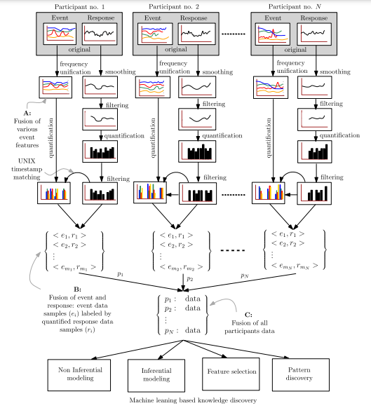

Figure 1 - Research Framework

##### 1.1 Signal Processing

**Frequency Unification**: The natural highlights sound and residue were gathered at 0.4 Hz recurrence; while GPS position, temperature, stickiness, and illuminance were gathered at 1 Hz recurrence. Subsequently, an up-examining component with a straight addition was applied to sound and residue information to bind together the frequencies of the accumulated information. All highlights were at that point adjusted to the equivalent timestamp, which was urgent to guarantee that all sensor esteems have a place with a careful occasion during the study.

**Signal Filtering and Smoothing:** The physiological reaction information (EDA signals) was kept at their unique 4Hz recurrence to keep up the data needed for excitement recognition from the physiological information. With close assessment, the authors tracked down that a few members EDA signals were unusable and were disposed of. The leftover (acknowledged) EDA signals were first smoothed and afterwards separated to eliminate antiquities as suggested in EDA writing.

**Physiological information determination:** The EDA signals from 30 members were dissected by contrasting the different "profiles." The EDA signals from four sorts of uncorrupt EDA profiles were considered for data analysis. The EDA signals having a place with the two incorrect EDA profile types. The mistaken EDA signal sorts were delegated:

1. Type-1 mistake, when EDA signal qualities just vary between two qualities, i.e., the EDA signal acted like a stage work, furthermore, the sign may likewise contain a lot of sensor misfortune (no sensor reaction record).
2. Type-2 mistake, when most of the example esteems were zero (huge sensor reaction misfortune), despite the something else ordinary variances (right sensor reaction) in EDA signal.

**Stationary Wavelet transformation based smoothing:** After selecting EDA signals, they were smoothed using SWT and reverse SWT. The EDA waves were recorded for 25 – 30 minutes before applying SWT smoothing.

**Unwanted Signal Fragments Truncation**: Sharp drops are the EDA waves that were not filtered out by the SWT; this procedure is to filter them out.

**Signal Quantification and Labelling:** Signal measurement included three stages: time-window marking, arousal detection, and data labelling. Indeed, these are the basic strides in the combination of natural information and physiological reaction information.

* Time-window Making: Each EDA sign's timestamp data were contrasted and the timestamps recorded at different stages during a members' walk. In light of the sign separating and accessible timestamp data, the sign part had a place with the strolling length—demonstrated by Start and End — which were set apart with a normal period window size t second. Such a period window checking was urgent to our information investigation to notice member’s physiological states corresponding to their experience of the occasions happening at a customary time second.
* Arousal Detection: The degree of excitement in an EDA signal relies upon recognizing a particular mark (design) called skin conductance reaction (SCR) or excitement. The condition of excitement in an EDA signal is normally characterized as a pinnacle having a particular signature. The authors prepared the EDA signals utilizing a skin conductance handling apparatus Ledalab. Ledalab offers a constant deterioration investigation (CDA) technique for dissecting an EDA signal. In CDA, an EDA signal is disintegrated into tonic skin conductance level (SCL) and phasic drivers SCR.
* Data labelling: For the naming of each time window—of every member information—a paired class name demonstrating a paired condition of phasic nSCR can be utilized, where:
  + class 0 is "ordinary" physiological reaction ("N"), i.e., a nSCR esteem equivalent to 0
  + Class 1 is a "stimulated" physiological reaction ("A"), i.e., an nSCR esteem more prominent than 0.

A multi-class arrangement was likewise utilized, in which case, excited physiological reaction, "A" has two classifications: class "LA" showing low excitement reaction, i.e., 0 < nSCR < 6 and class "HA" demonstrating high excitement reaction, i.e., nSCR ≥ 6. An aggregate of 6057 examples and 9 info highlights were accessible in the ordered dataset for a period window size t (evaluation rate) of 5-s. In the gathered information, 3491 examples had a place with the classification "N" and 2566 examples had a place with the class "A," i.e., roughly 60% and 40% of the examples separately have a place with "N" and "A." Furthermore, in the multiclass order, 2079 examples were named "LA" and 487 examples were marked "HA".

##### Machine Learning

###### 2.1 Non-inferential Modelling

The authors construct a prescient model comprising of the natural highlights as the information sources, and paired (and multiclass) measured excitement level as the yield utilizing REP-Tree, which is a choice tree student. The authors picked REP-Tree (a decision tree that implements ‘Reduced Error Pruning’ method that prunes the Decision tree without losing significantly important sub-trees) to fabricate a prescient model because the calculation develops a choice tree, where every hub chooses for a component, and its particular worth creates a specific class mark. For the approval of the model's prescient exhibition, the authors picked ten times cross-approval.

###### 2.2 Inferential Modelling

Inferential demonstration clarifies the connections between the info highlights and the yield highlight. A fuzzy principle-based derivation framework is equipped for depicting how autonomous ecological highlights are identified with the ward physiological reaction (phasic nSCR) include. For this, the authors applied FURIA, which is a fuzzy rule-based classifier.

##### Results

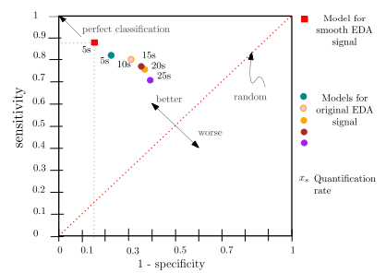

Figure 2 - Performance Metrics for REP-Trees

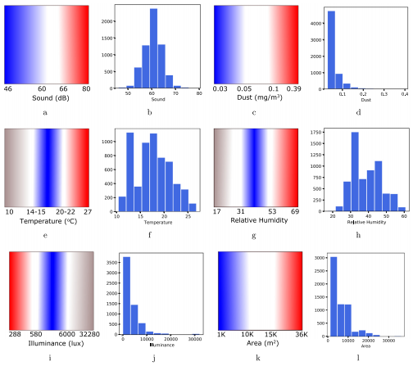

Figure 3 - Results obtained from visualizing fuzzy rules

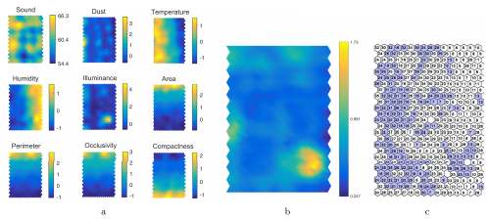

Figure 4 - Trained SOM Results

### LR-02 Psychological and physiological human responses to simulated and real environments: A comparison between Photographs, 360 Panoramas, and Virtual Reality.

This paper plans to approve three natural recreation show designs: photos, 360 scenes, and computer-generated reality. To do this the authors analyzed the mental and physiological reactions evoked by reproduced conditions set-ups to those from an actual climate arrangement; the authors likewise evaluated the clients' feeling of quality. Investigation shows that 360 displays offer the nearest to the real-world results as indicated by the members' mental reactions, and computer-generated reality as per the physiological reactions.

#### Environment Setup

The writers chose an inside shopping climate because past work has effectively assessed the authenticity of this sort of climate and the utilized surveys had effectively been approved. This climate is likewise adequately complex to assess spatial highlights, and its measurements and attributes make it ideal for producing a virtual climate.

* Physical Environment set-up: an actual model of the environment was implicit in our exploration space; this included a 4.5 m 4.5 m white room with an entryway, a window, and two shelves inverse to one another containing a few brew brands.
* VR climate set-up: An intelligent tridimensional reproduction created through the Unity game motor. The model was produced in SketchUp 2015 and the surfaces were separated from the actual climate to accomplish the most extreme authenticity. The planned climate contained 15.546 polygons and 112 surfaces. As a mechanical gadget, a Samsung Stuff VR HMD was utilized. Member's collaboration comprised on the following of the head direction of this gadget, and the route everywhere on the climate utilizing a remote joystick.

#### Experiment

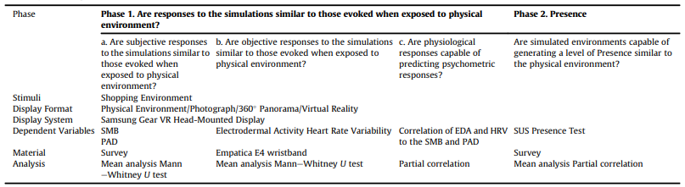

Figure 5 - Summary of the Experiment in this research

#### Results

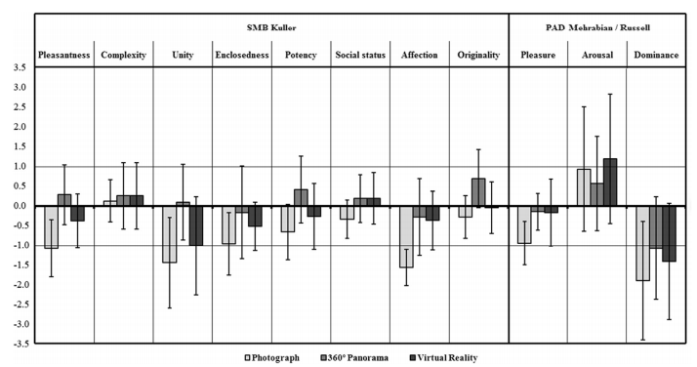

Figure 6 - Results as psychological responses.

# Project Timeline

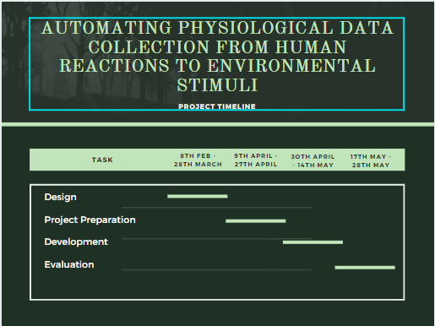

Figure 7 - Project Timeline

# Methodology

This research aims to provide a way to automate the collection of physiological data from human-environment interaction for furthering behavioural research. To that extent, Machine Learning will be implemented with a GUI element that will help interact with the database and the business logic.

## Dataset

The dataset will be provided from the OASIS study. The OASIS study will conduct a study on various micro-expressive reactions based on the pre-planned stimulus to which the subjects will not be privy. This dataset will be the source of training for the Machine Learning Algorithm.

## Machine Learning

The paradigm based on the research question and the dataset selected will be the multi-class classification paradigm. The algorithm used for this would be Convolutional Neural Networks. The reason behind this selection is because the algorithm will be dealing with real-time image data. The number of layers and nodes in each layer will be decided after further testing and research. Using LSTMs or R-CNNs is also an option to give the algorithm the power to digest video input as well.

The machine learning algorithms will be provided by Python-based Machine Learning libraries like tensor-flow and Keras. These libraries have an excellent implementation of Convolutional Neural Networks (CNNs) which will be beneficial to this project. The CNN from these libraries will be trained using the dataset collected from the OASIS study. The possibility of pairing CNNs with Long-Short Term Memory (LSTM) networks does exist although this will be decided after further testing.

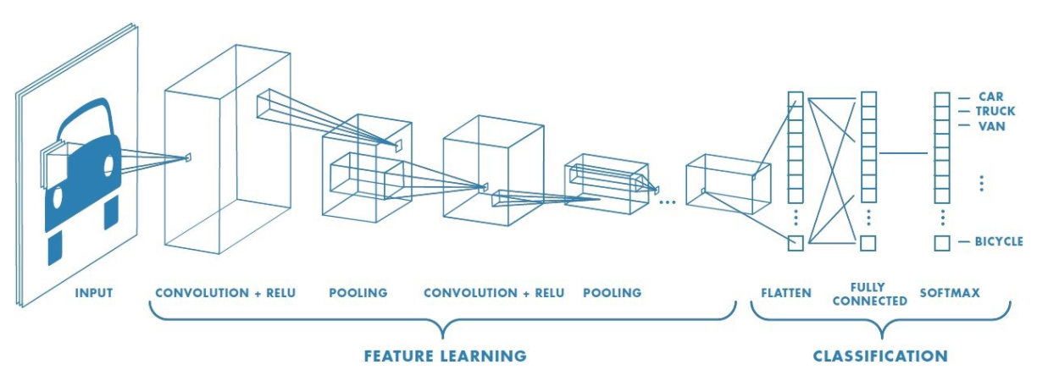

Figure 8 - Convolutional Neural Network Workflow

## GUI

The GUI element has two main functionalities:

* Provide access to camera hardware that will take photos or record videos for the algorithm
* Provide access to the database being created by the algorithm

# Project Evaluation

The project’s evaluation will be done by extensively observing and testing the dataset created by the Machine Learning algorithm. This might involve a domain expert i.e., a behavioural researcher.

# Conclusion

The importance of behavioural research can be found in many different applications like GUI design and problem solving especially problems related to living conditions in societies in metropolitan areas. The involuntary reactions of humans to a certain environmental stimulus can convey a lot of information. However, these aren’t easy to collect as a dataset. This research aims to automate the process of this data collection using machine learning and computer vision.

# References

* Hedblom, M., Gunnarsson, B., Iravani, B., Knez, I., Schaefer, M., Thorsson, P. and Lundström, J., 2019. Reduction of physiological stress by urban green space in a multisensory virtual experiment. Scientific Reports, 9(1).
* Higuera-Trujillo, J., López-Tarruella Maldonado, J. and Llinares Millán, C., 2017. Psychological and physiological human responses to simulated and real environments: A comparison between Photographs, 360° Panoramas, and Virtual Reality. Applied Ergonomics, 65, pp.398-409.
* Ojha, V., Griego, D., Kuliga, S., Bielik, M., Buš, P., Schaeben, C., Treyer, L., Standfest, M., Schneider, S., König, R., Donath, D. and Schmitt, G., 2019. Machine learning approaches to understand the influence of urban environments on human’s physiological response. Information Sciences, 474, pp.154-169.
* Zhao, G. and Li, X., 2019. Automatic Micro-Expression Analysis: Open Challenges. Frontiers in Psychology, 10.